**Local Environment preparation for front-end development**

This guide explains how to set up your environment for Angular development using the [Angular CLI tool](https://angular.io/cli). It includes information about prerequisites, installing the CLI, and running that app locally.

* **Prerequisites**

To install angular in the local system you need the following.

* **Node.js**

Angular requires a [current, active LTS, or maintenance LTS](https://nodejs.org/about/releases) version of Node.js. Please

visit [**https://nodejs.org/en/**](https://nodejs.org/en/) to download and install node in your environment.

* **npm package manager**

Angular, the Angular CLI, and Angular applications depend on [npm packages](https://docs.npmjs.com/getting-started/what-is-npm) for many features and functions. To download and install npm packages, you need an npm package manager. npm package manger is installed with Node.js by default. To check that you have the npm client installed, run npm -v in a terminal window.

* **Install Angular CLI**

Angular CLI helps you to create projects, generate application and library code, and perform a variety of ongoing development tasks such as testing, bundling, and deployment.

To install the Angular CLI, open a terminal window and run the following command:

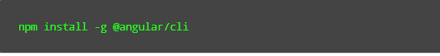

* **Run the Application.**
* Unzip file
* Navigate to the workspace folder, such as simple-chat-ui.

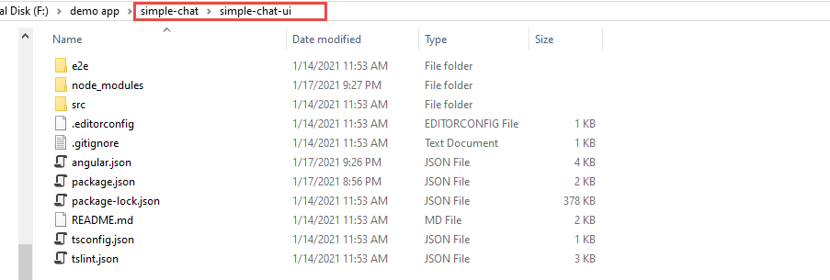

* Open terminal window
* Run **npm install** to install all packages used in application.

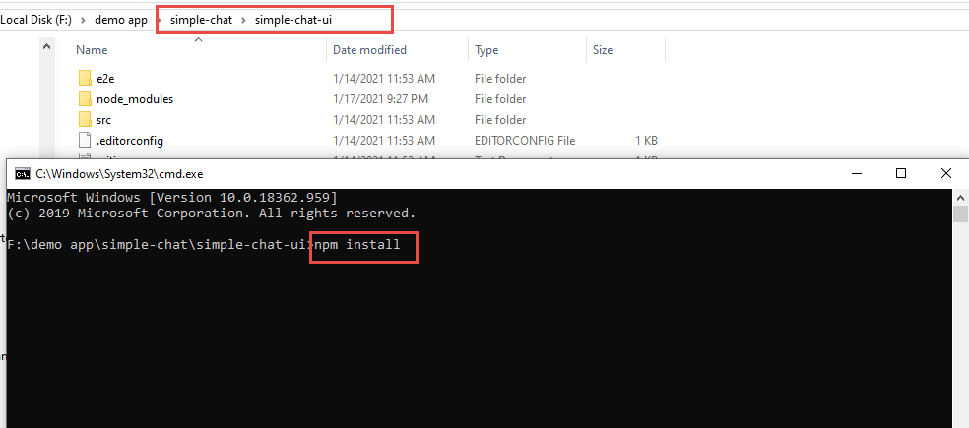

* Write **npm start** to run the application. And browse <http://localhost:4500> to view the chat app.

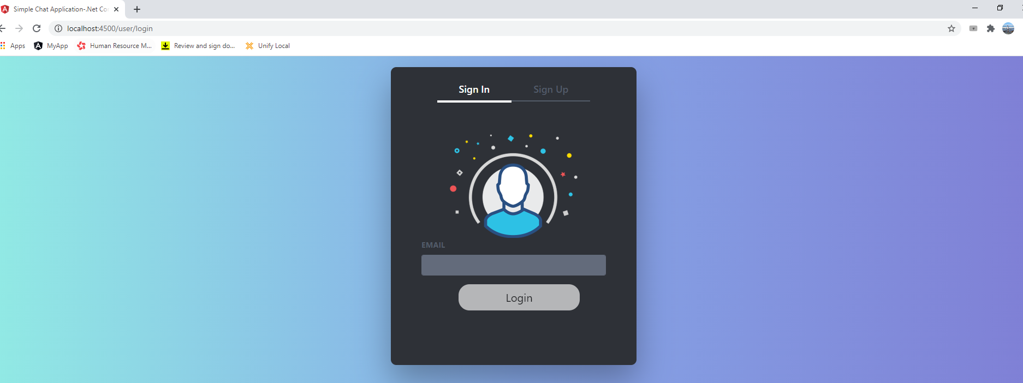

**Local Environment preparation for Back-End Development**

This guide explains how to set up your environment for back end development. It includes information about installing SQL Server, installing Visual Studio 2019, installing .Net Core SDK 3.1, updating database from package manager console using code first command and running the back end app locally.

* **Install Microsoft Sql Server**

This application uses current version of Microsoft SQL server to store and to retrieve data. Please visit [**https://www.microsoft.com/en-us/sql-server/sql-server-downloads**](https://www.microsoft.com/en-us/sql-server/sql-server-downloads) to download Sql server.

* **Install Microsoft Visual Studio**

Microsoft Visual Studio is full-featured IDE to code, debug, test, and deploy to any platform. This IDE will help you to run the back-end part of chat application locally. Please visit [**https://visualstudio.microsoft.com/downloads**/](https://visualstudio.microsoft.com/downloads/) to download community version of visual studio 2019.

* **Install .Net Core 3.1 SDK**

Please visit <https://dotnet.microsoft.com/download/dotnet-core/3.1> to download dotnet core sdk 3.1. This chat application uses 3.1 version of .net core to build backend application on dotnet core.

* **Deploy Database**
* Please use your own connection string in appsettings.json

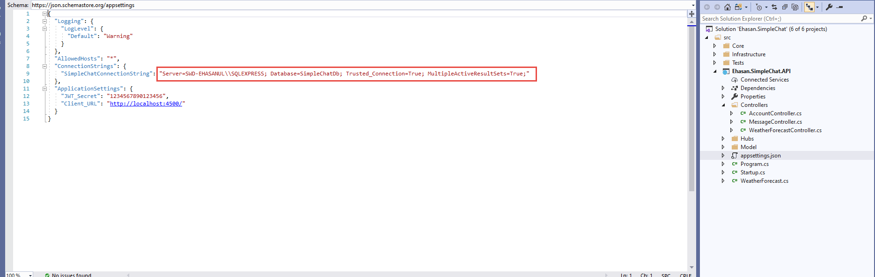

* Update Database

Back-end of chat application uses code first approach of entity framework core. All migration code is in infrastructure/ Ehasan.SimpleChat.DataRepositories. please run **update-database** command from package manager console by choosing Ehasan.SimpleChat.DataRepositories project.

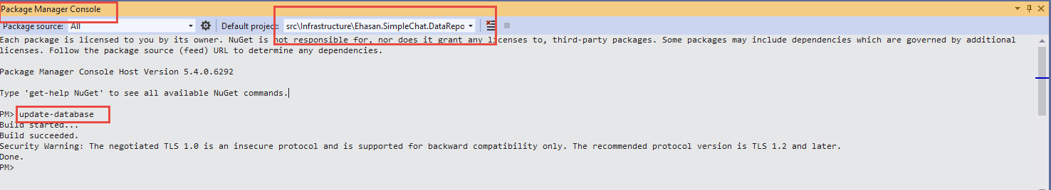

Now SimpleChatDb database has been created in your database server.

* **Run Application**

Run backend app using Visual Studio 2019

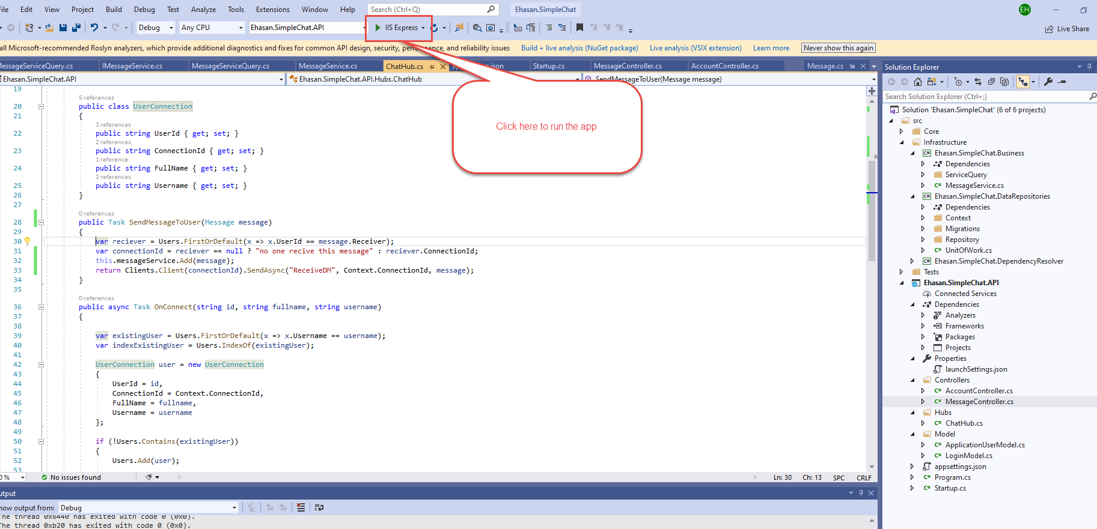

Browse <https://localhost:44381/swagger/> to view backend app

